**DROPSHIPPING PRODUCT ANALYSIS**

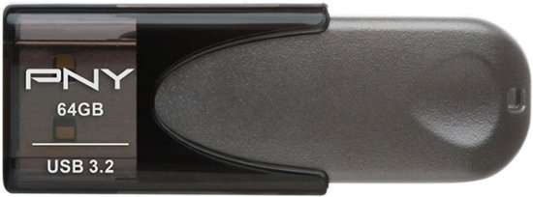

**Product Name:** **PNY - Elite Turbo Attache 4 64GB USB 3.2 Flash Drive - Black**

**Price:** **$6.99**

**Product Link:** [Click here](https://www.bestbuy.com/site/pny-elite-turbo-attache-4-64gb-usb-3-2-flash-drive-black/1876003.p?skuId=1876003)

**DESCRIPTION**

PNY's Elite Turbo Attache 4 USB 3.2 is built for speed & convenience. Experience USB 3.2 next generation speed performance with transfer speeds of 100MB/s read and transfer speeds up to 10x faster than USB 2.0. It's the perfect solution for easily storing and quickly transferring all your large documents, high-resolution photos, HD videos, and more. USB 3.2 offers the same ease-of-use and plug-and-play capabilities as previous generations of USB technologies, but with exceptional speed improvements. Designed for Reliable Portable Storage, PNY's Elite Turbo Attaché 4 USB 3.2 Flash Drive is designed with convenience and portability in mind. The portable, light-weight Flash Drive incorporates a sliding collar cap-less design that means for no more lost caps. This USB 3.2 Flash Drive is small in size, but big on performance

**Date**

**7/15/2024**